Chapter 9, Solution 42.

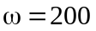
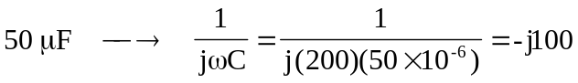
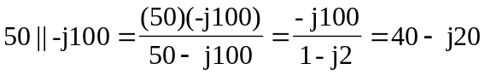

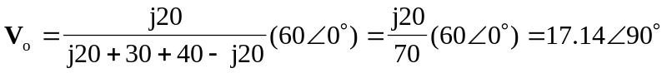
Thus,
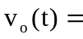 17.14 sin(200t + 90) V
or
17.14 cos(200t) V

